**TOBI Programming Guide**

# Setting up Arduino Environment

1. Download tobi.zip from **TOBI 3 Finals > Tobi Programming** in Google Drive.
2. Open the Arduino compiler, go to ‘Sketch > Include Library > Add .ZIP Library…’ from the menu bar and choose the tobi.zip file you created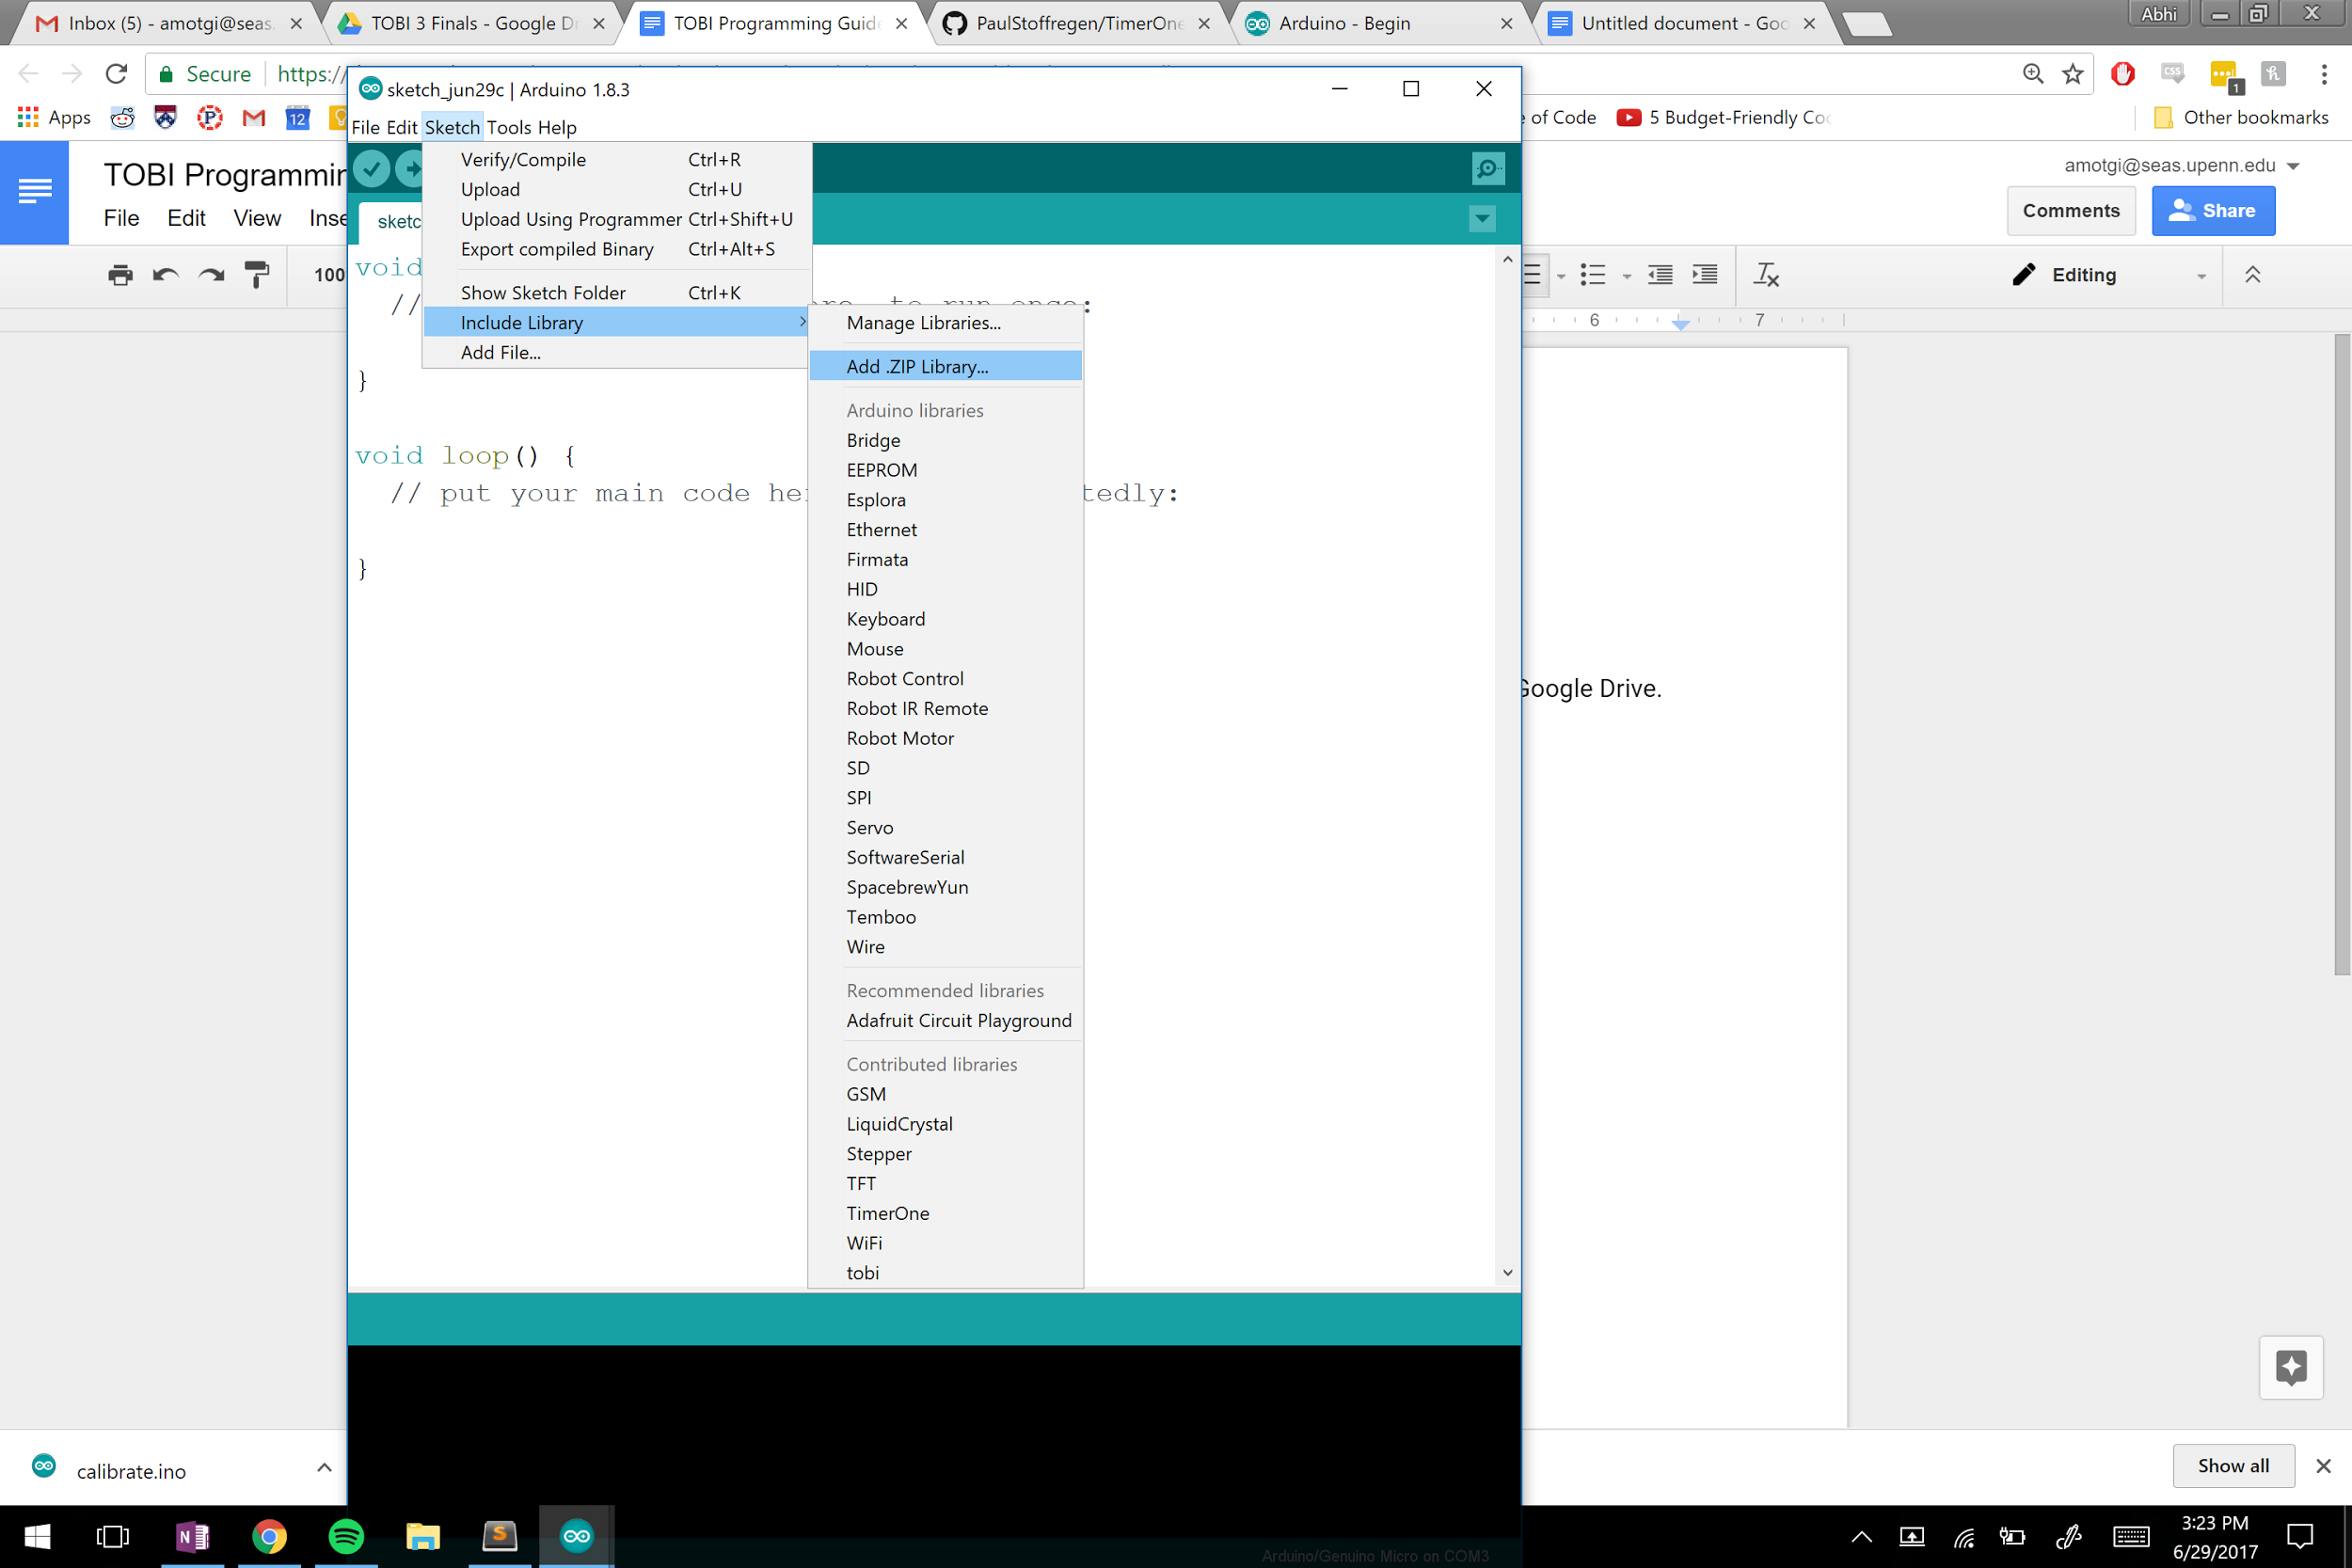
3. From the same window, click ‘Sketch > Include Library > Manage Libraries…’ and install the ‘TimerOne’ library

# Example Tobi Program: Read Encoder 5

#include <tobi.h>

#include <Wire.h>

//make a tobi variable

tobi t = tobi();

void setup() {

// set data rate for serial data transfer

Serial.begin(9600);

//enable tobi object

t.enable();

// set direction for the motors so they go correct direction when powered

t.setMotor(0,-1); // 1

t.setMotor(1, -1); // 2

t.setMotor(2, 1); // 3

t.setMotor(3, -1); // 4

t.setMotor(4, 1); // 5

t.setMotor(5, -1); // 6

// sets some unknown encoder field? 255 is the most accurate

t.setPwm(0,255);

t.setPwm(1,255);

t.setPwm(2,255);

t.setPwm(3,255);

t.setPwm(4,255);

t.setPwm(5,255);

}

void loop() {

// put your main code here, to run repeatedly:

// updates encoders?

t.analogUpdate();

// read encoder angle (from 0 - 729?)

// Serial.println(t.getAngle(0));

// Serial.println(t.getAngle(1));

// Serial.println(t.getAngle(2));

// Serial.println(t.getAngle(3));

// Serial.println(t.getAngle(4));

Serial.println(t.getAngle(5));

}